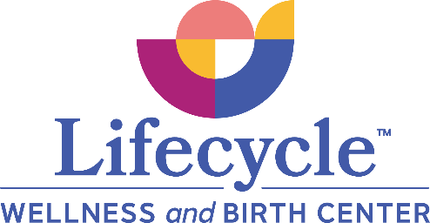

BIRTHING HOPES AND DREAMS

You have already begun to create your own image of your birth without even knowing it. Choosing The Birth Center was your first choice in deciding the kind of birth experience you want to have. We would like you and your partner to write down your hopes for your birth. Birthing is not a matter of success or failure but is an active process in which you are able to share decision-making about your body, as you have been throughout your prenatal care. Thus, we are trying to get away from the words “birth plan”, realizing that birth cannot really be planned for. It can be anticipated, dreamed about, wished and hoped for. We would appreciate something written down and ask you to think about these things:

- What are our visualizations about how this birth will be?
- What are our hopes and fears about our birth experience?
- Are there any affirmations that would be helpful?
- What will it take for me to feel confident and comfortable (both physically and emotionally) or what can I foresee that would impede my comfort?

Consider it more a work in progress rather than a birth plan, as laboring and birthing are always processes that reveal themselves as they unfold.

Other suggestions to consider:
- Who will be with you and what will their roles be?
- How have you coped with pain in the past?
- How do you and your support person react to pain? What can we do to help your support person?
- Any birth preferences? Does someone want to assist in the birthing of your baby? Take pictures? Cut the cord? Any special requests for who will announce the sex of the baby? Requests for washing and dressing the baby by the family?

Please make some notes about the possibility of transfer to the hospital. Indicate that you want your partner with you at all times and preferences regarding rooming in. Know that we will be with you and will help you through your birth, whatever might come.

